**Name:** Chillara V L N S Pavana Vamsi

**Reg.no:** 21BCE5095

**Date:** 12/1/2023

**Faculty:** M Sivagami

## 

## L21_L22_Lab4 Exercises

* + 1. 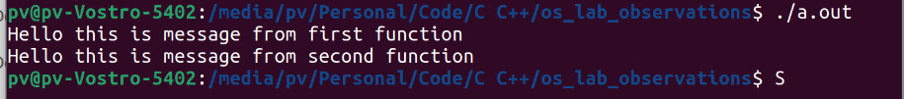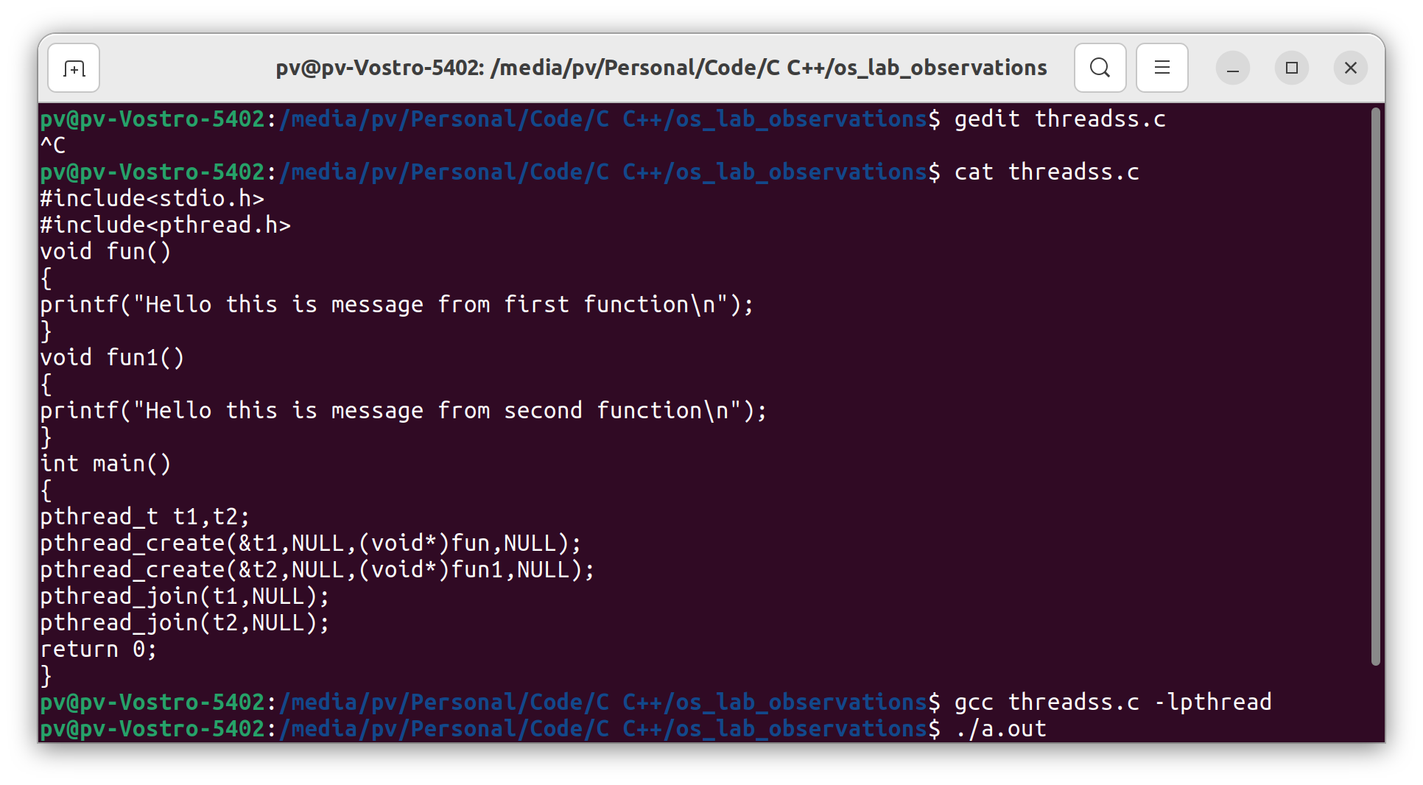Design two threads to display two different messages using two different functions.
    2. 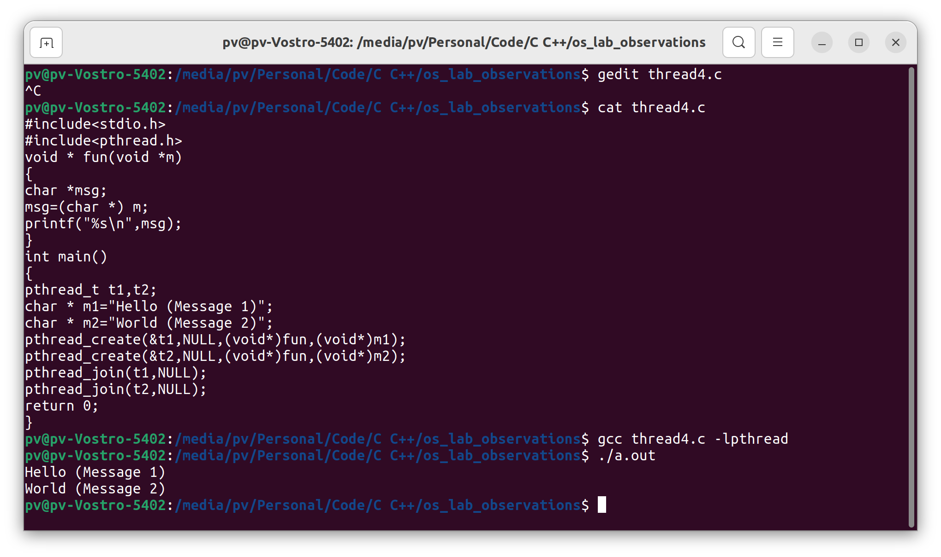Design two threads to display two different messages using single function.
    3. 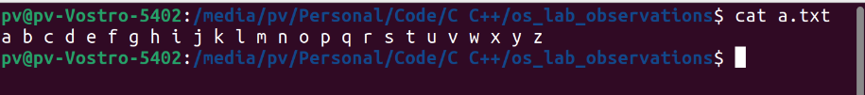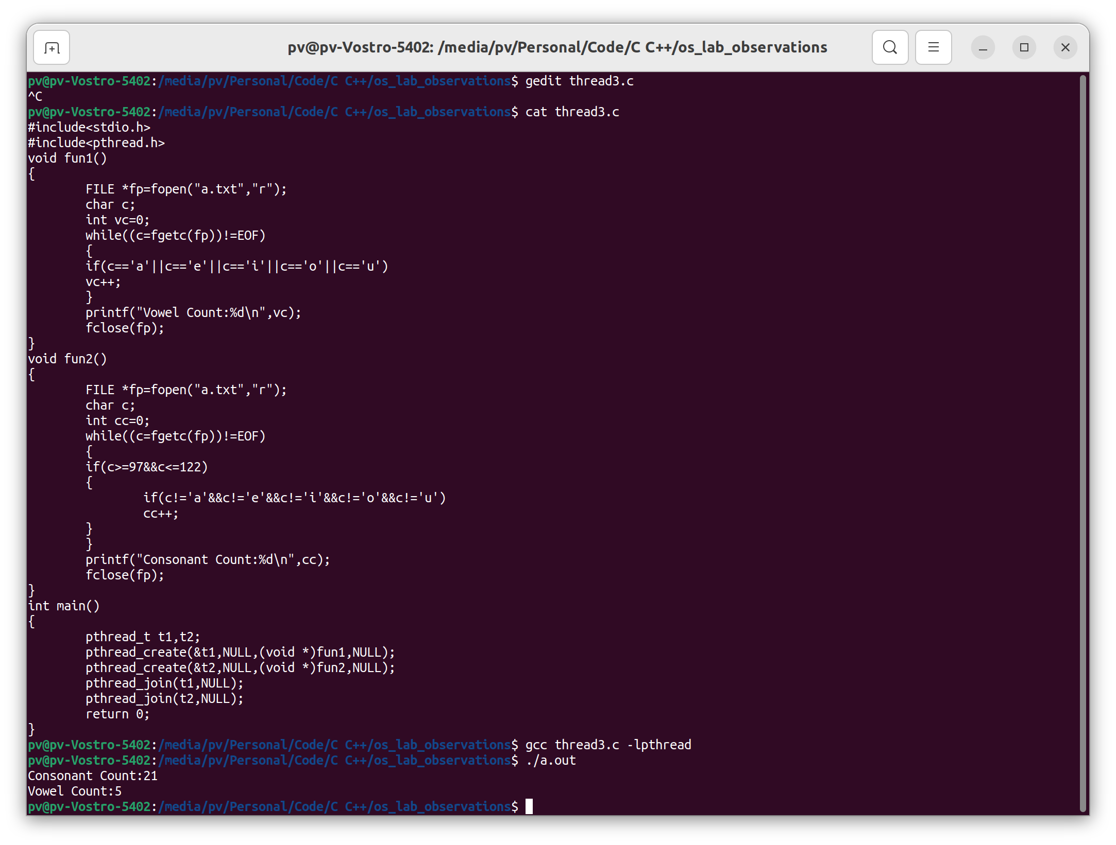Design two threads to count the vowels and consonants either from "a.txt" file or a given string.
    4. Design two threads to display the numbers (i) from 1 to 10000 (ii) from 10001 to 20000 using (a) two different functions or (ii) single function. Discuss the nature of the output generated by the two threads in command prompt.
* **Two different functions:**

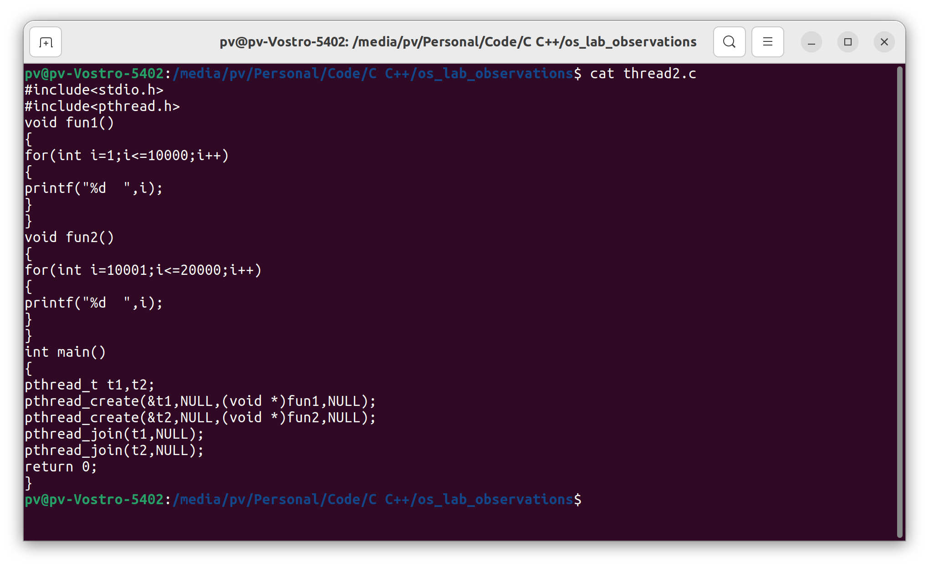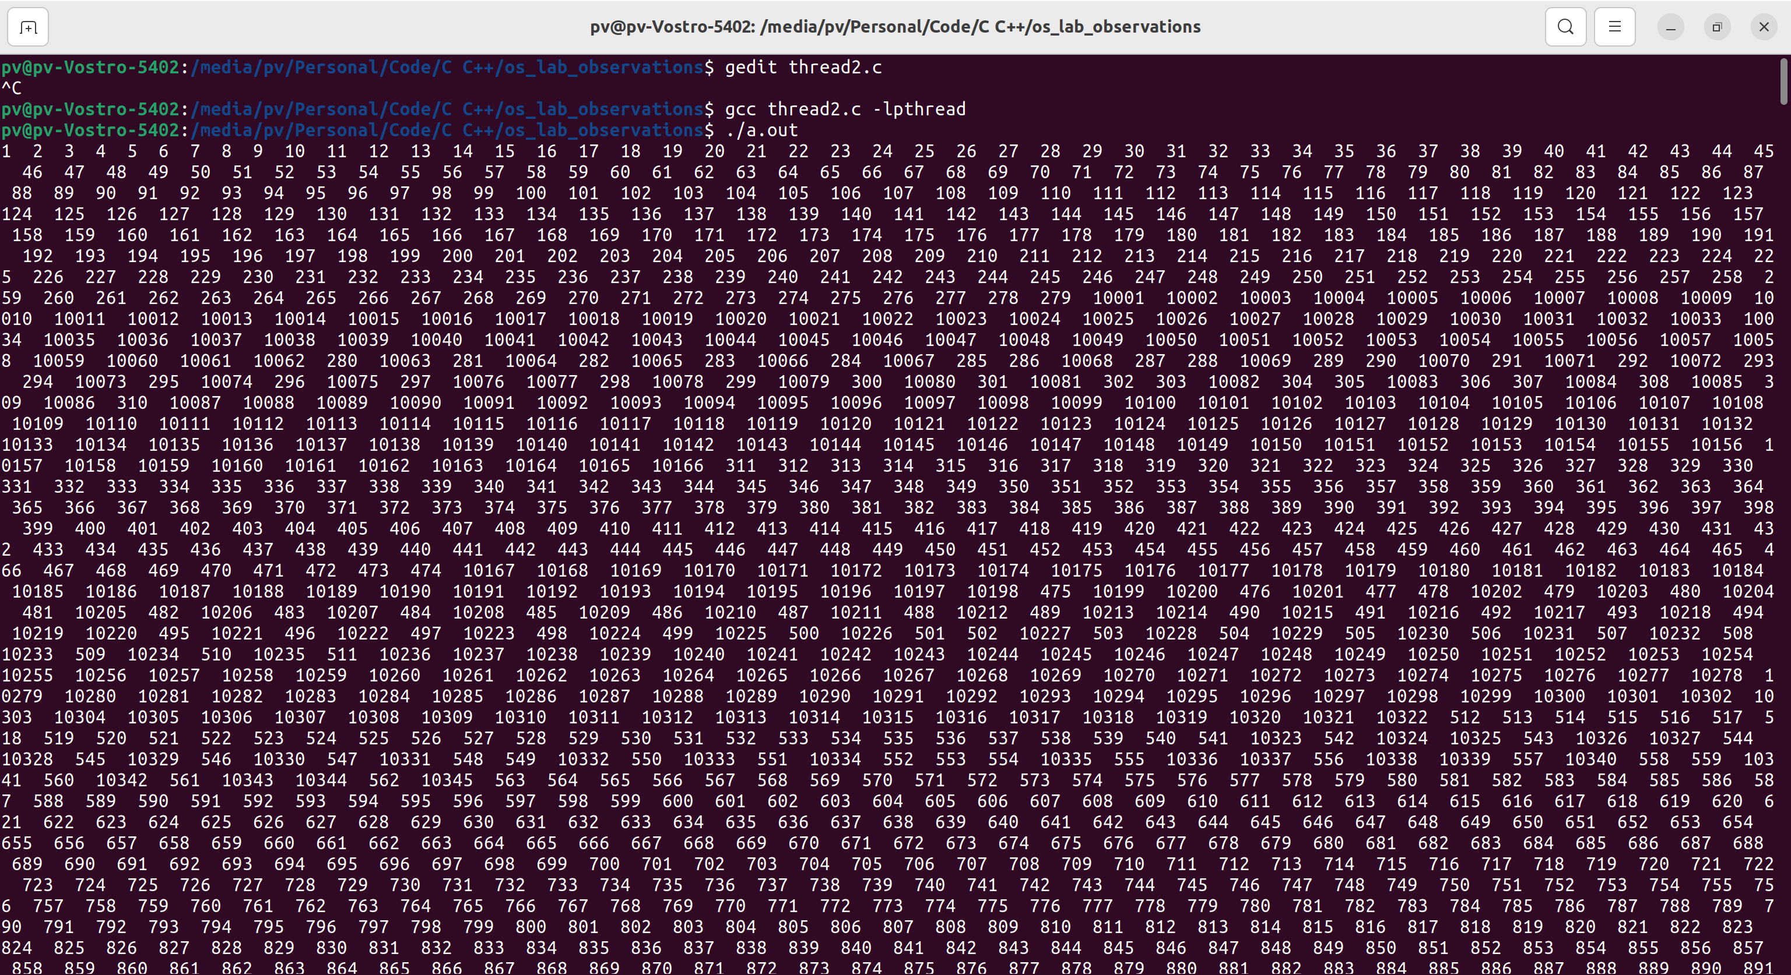Here two threads functions run simultaneously so the numbers come in mix of both 1st function and 2nd function.

**Single function:**

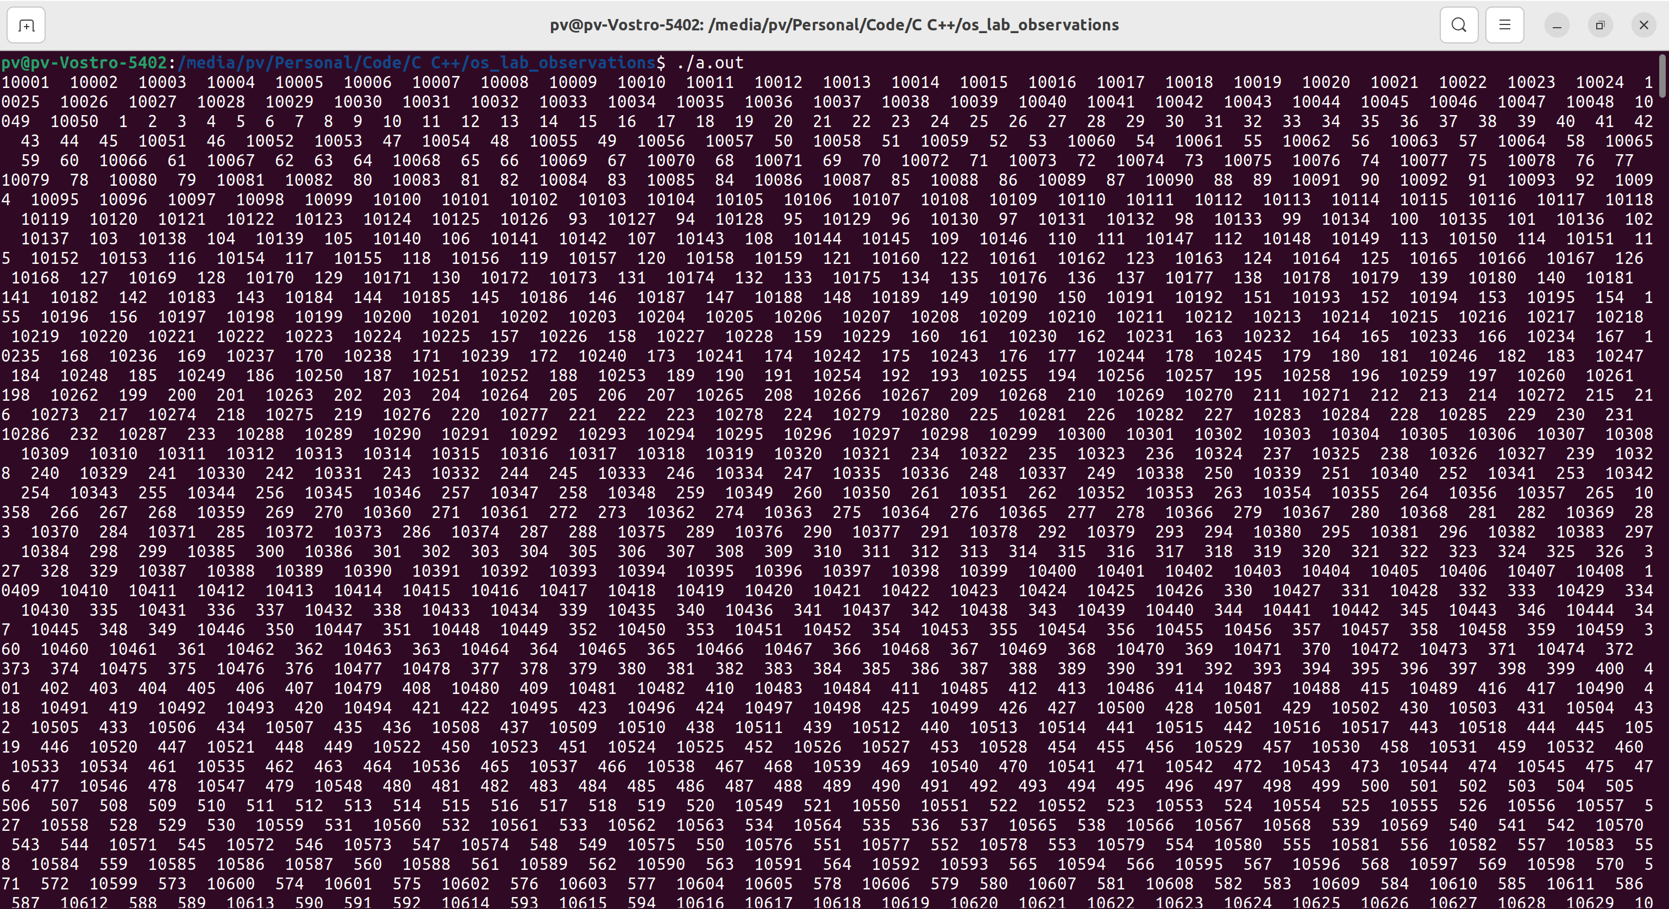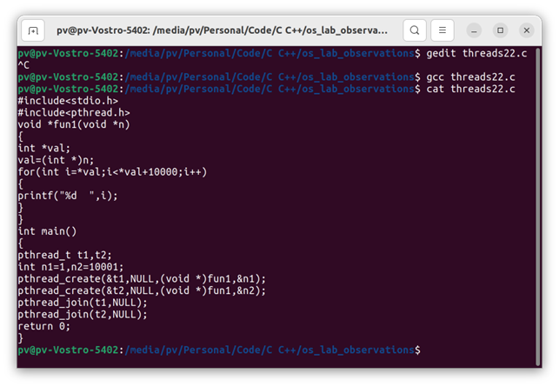Here both threads are running simultaneously in that process.So, the numbers print in zig-zag order.

* + 1. 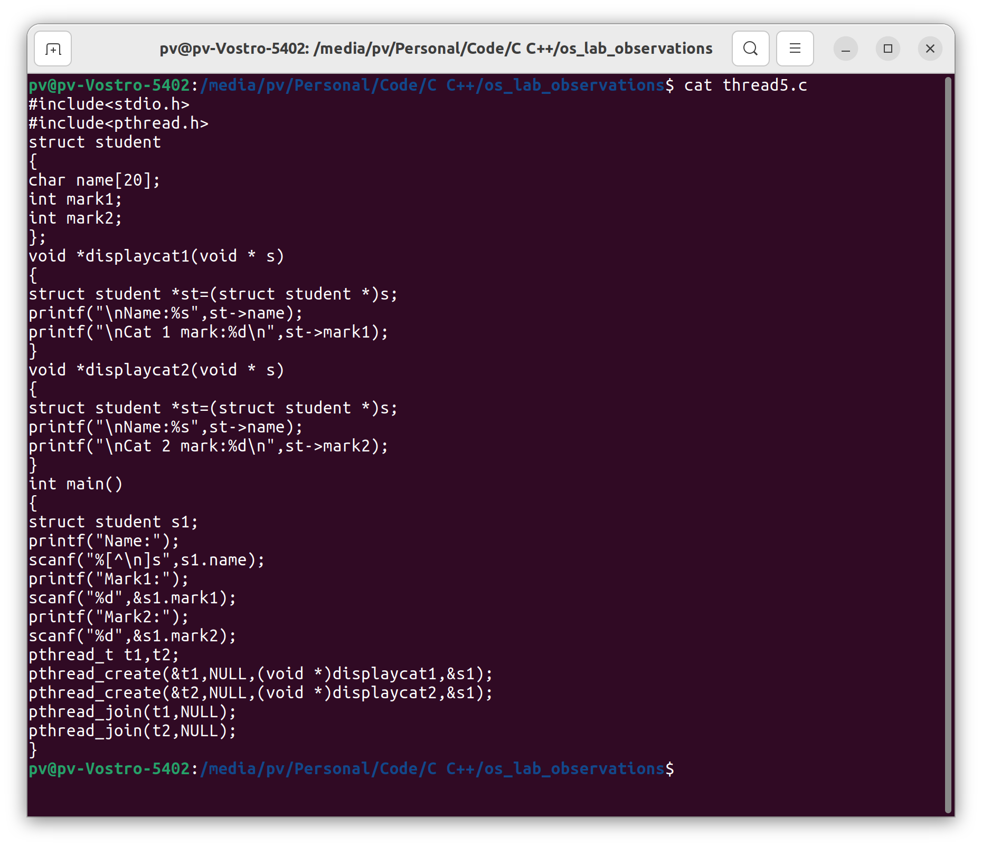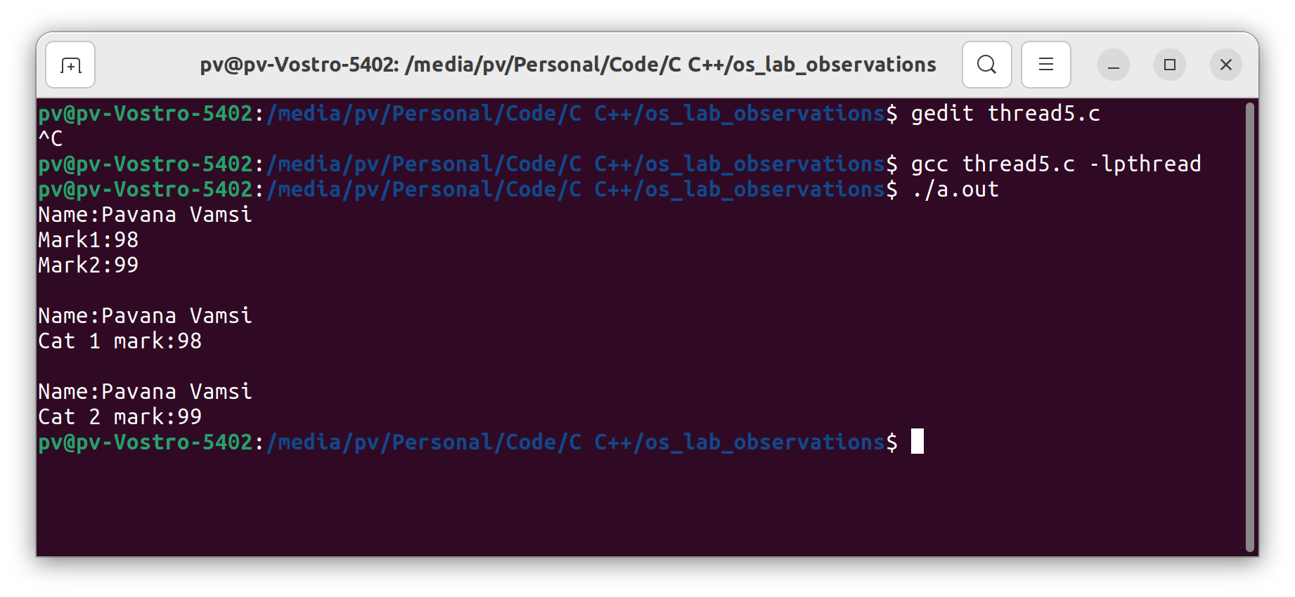Design two threads to display the student name and CAT1 mark by first thread and student name and CAT2 mark by second thread using struct data type for a single student (tutorial:<https://www.w3schools.blog/how-to-pass-a-struct-value-to-a-pthread-in-c> ) in this website the header files have not been included - you include it and refer this web site for passing structure and modify as per the question.
    2. 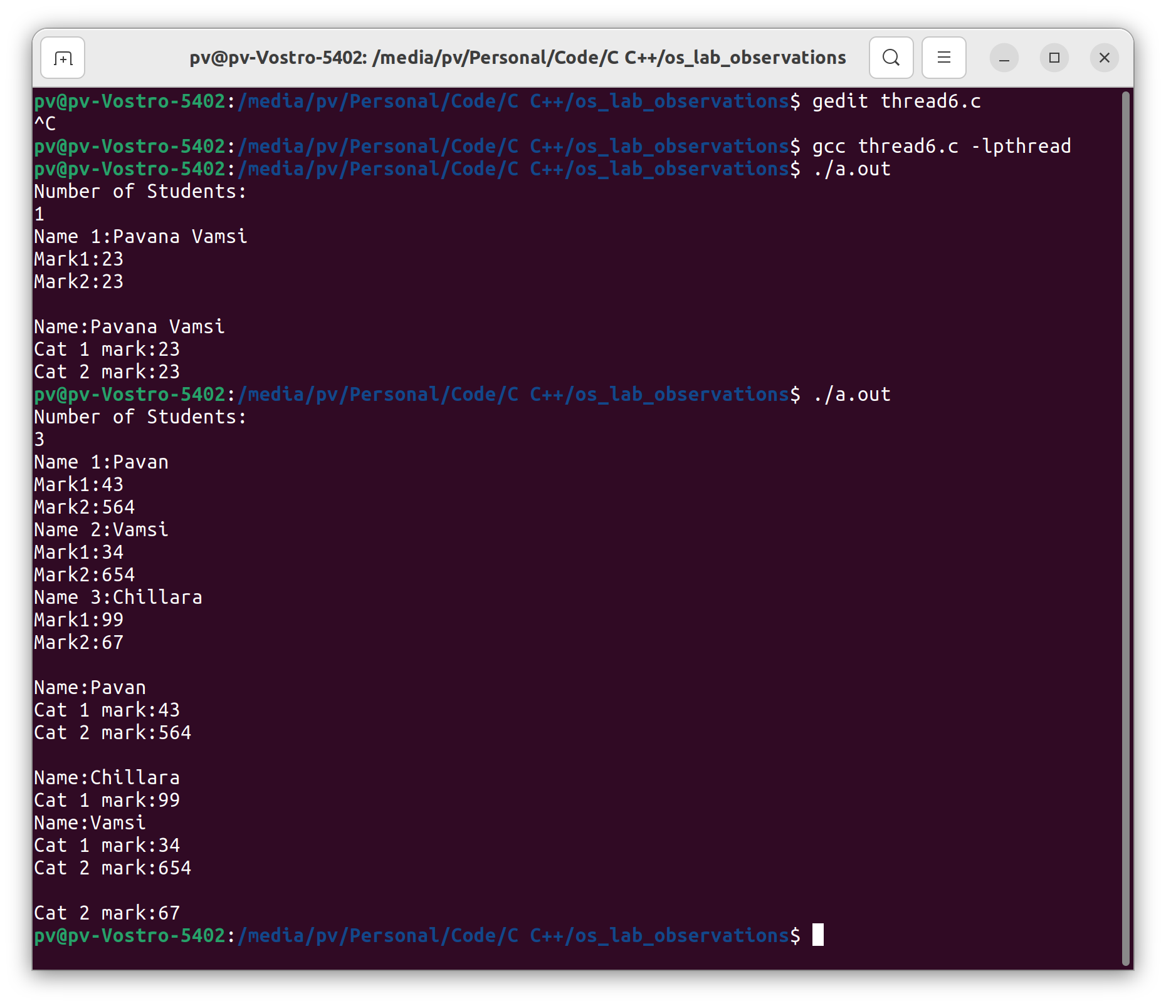Implement the same program for array of students of class strength 70 and analyse the output generated by the program.

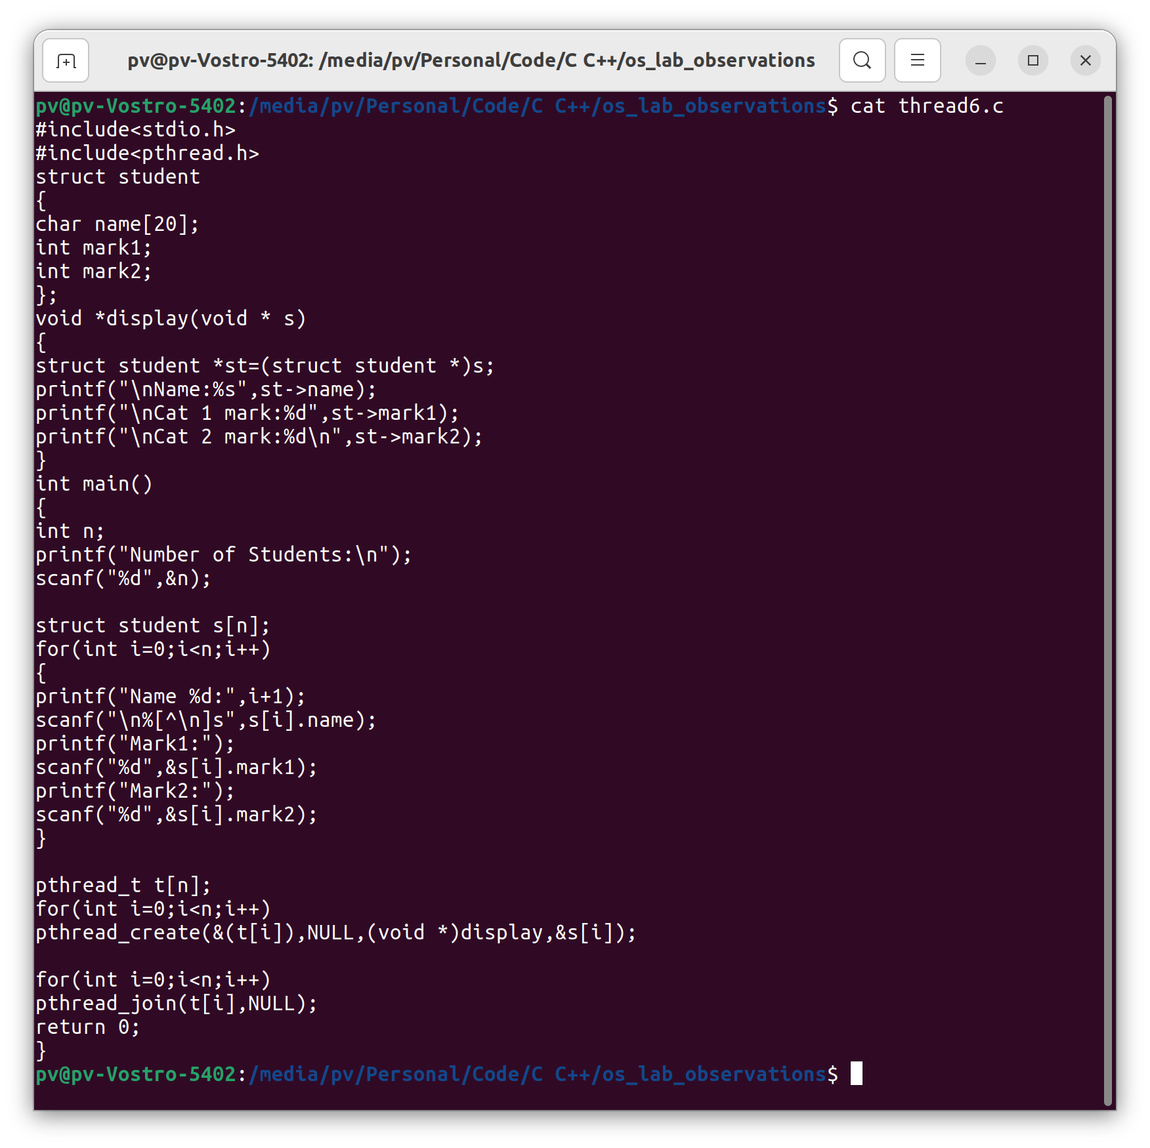

* + 1. 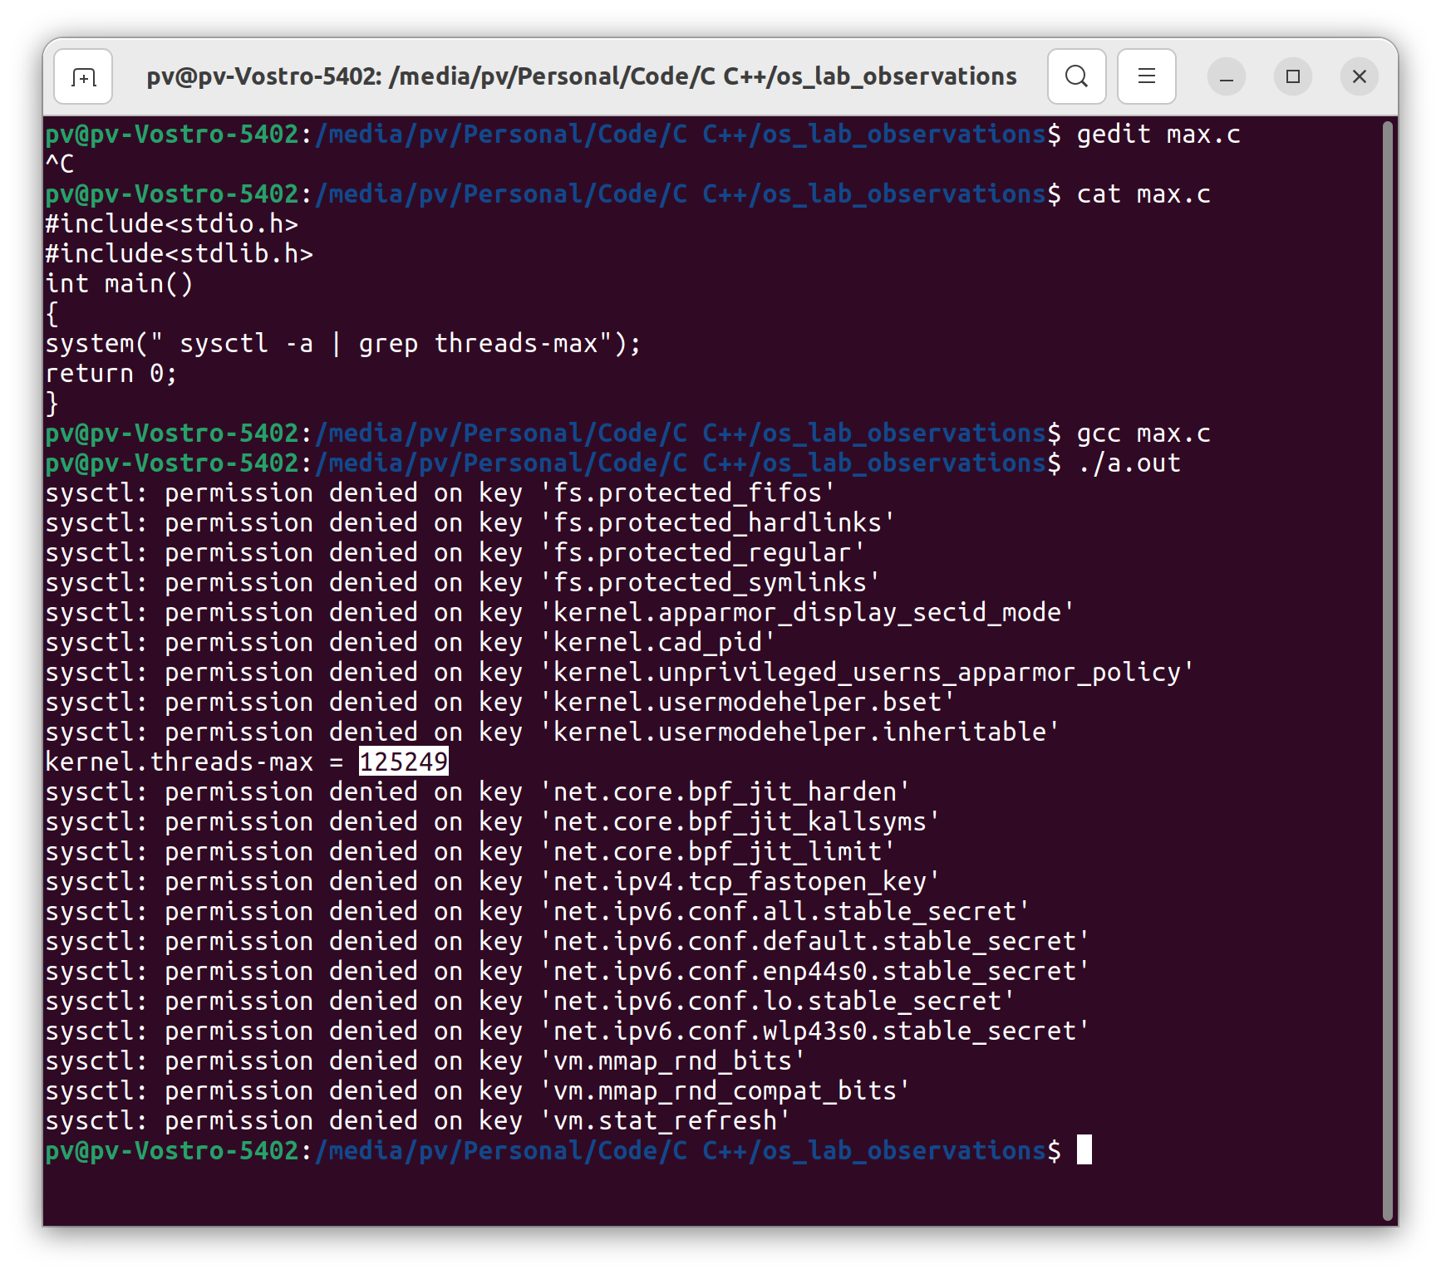Find out the maximum number of threads your system can generate?
    2. 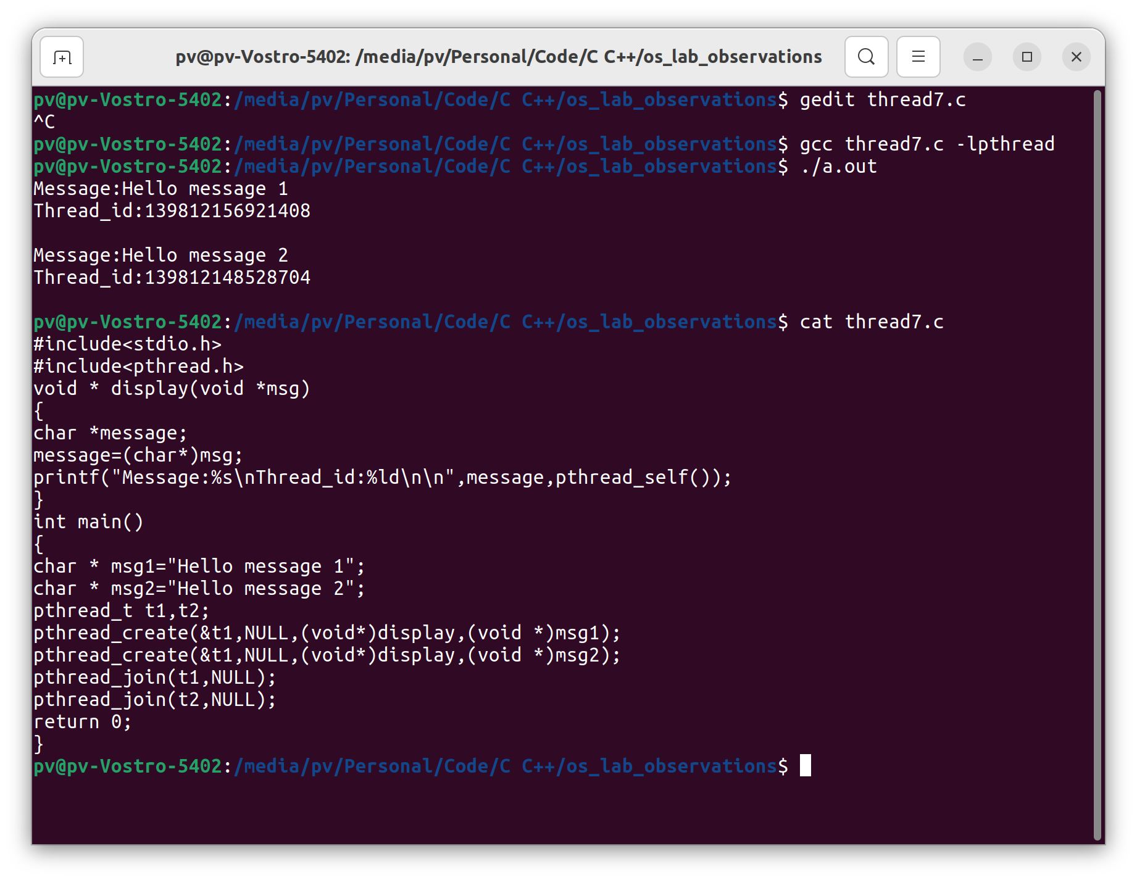Create two threads and display the two messages along with the corresponding thread_id. (pthread_self () function returns thread id)